“Washing Machine Details”

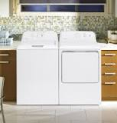If you're in the market for a new washing machine, you'll run into three main types: **top load agitator, front load, and top load impeller** (or high efficiency). Each one has different pros and cons, and with the right information, you'll be able to choose the ideal one for you.04-Apr-2019

|  |  |  |
| --- | --- | --- |
| **S No.** | **Product Name** | **Price** |
| 1 | **Panasonic** 5 Star Fully Automatic Top Load Washing Machine - NA-F70L9MRB | Rs. 17190 |
| 2 | Samsung Inverter Fully-Automatic Front Loading Washing Machine | Rs. 32,990 |
| 3 | Whirlpool 5 Star Fully-Automatic Top Loading Washing Machine | Rs. 22,330 |

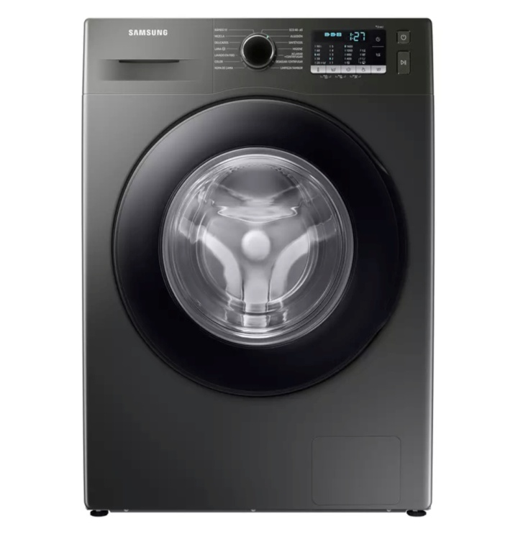**Series Front Loading**

HRF-758S-7682

DD INVERTOR MOTOR  
UV LIGHT  
DUAL SPRAY

**PKR 39,990.00**